A Mini Project Report Of
PCC-201-COM : Data Structures
Implementation of Palindrome checker [Stacks and Queues]

Submitted by

ROHAN TANAJI KUMBHAR(38)

Under the Guidance of
Prof. Tejal.H.Patil



Department of Computer Engineering

BHARATI VIDYAPEETH’S

COLLEGE OF ENGINEERING, LAVALE, PUNE, 412115

Savitribai Phule Pune University

[2026-27--]
BHARATI VIDYAPEETH

COLLEGE OF ENGINEERING, LAVALE, PUNE

CERTIFICATE

This is to certify that the “Mini Project Report” submitted by ROHAN TANAJI KUMBHAR(38) ,on “Implementation of Palindrome checker [Stacks and Queues]” is work done by her and submitted during 2025–2026 academic year, in partial fulfillment of the requirements for the award of the degree of Bachelor of engineering in computer Engineering, at Bharati Vidyapeeth’s College of Engineering, Lavale, Pune.

Prof. Tejal. H . Patil Dr. Lalit . V . Patil (Guide) Head of Computer Engg. Department

ACKNOWLEDGEMENT

It gives immense pleasure to express our gratitude & thanks to all those who have helped in the timely completion of the Mini-Project work. We have a great pleasure in expressing our deep sense of gratitude and indebtedness to Prof. Tejal. H . Patil Guide for their invaluable guidance, constant supervision and sustained encouragement throughout the tenure in this Mini Project work.
We would like to express our thanks to Dr. Lalit . V . Patil, Head of Department, Department of Computer Engineering Bharati Vidyapeeth’s College of Engineering, Lavale, Pune for their constant support and encouragement.
We would like to express our thanks to Prof. Dr. R. N. Patil Principal, Bharati Vidyapeeth’s College of Engineering, Lavale, Pune for permitting us to take up the project work. We are thankful to our parents and friends for their kind help and support throughout the course.

ROHAN TANAJI KUMBHAR
Student Name

ABSTRACT

In computer science and data structure design, string processing and sequence verification are foundational operations. A classic problem in this domain is checking for palindromes—sequences of characters that read the same forwards and backwards. Efficiently verifying palindromic properties requires linear time processing and flexible linear data structures.
This project presents a Palindrome Checker implemented using two fundamental linear data structures: Stacks and Queues. By leveraging the Last-In, First-Out (LIFO) property of a Stack alongside the First-In, First-Out (FIFO) property of a Queue, the system processes input characters simultaneously. As characters are pushed into the Stack and enqueued into the Queue, the natural order of elements is reversed in the Stack while preserved in the Queue. Comparing elements popped from the Stack and dequeued from the Queue character-by-character allows the system to determine palindromic validity in $O\left(N\right)$ time complexity and $O\left(N\right)$ space complexity.
Additionally, the system includes preprocessing modules for case insensitivity, removal of non-alphanumeric characters (punctuation and whitespace), and validation of edge cases (such as single-character inputs and empty strings). This implementation highlights the practical synergy between Stacks and Queues in dual-ended sequence analysis and memory management.

Acknowledgement i
Abstract ii
Content iii
List Of Figures iv
TABLE OF CONTENTS

SR.NO.

CONTENT

PAGE NO.

- Introduction 1
  - Overview
  - Problem Statement
  - Objective
- Literature Survey 2
- UML Diagram 3
- System Requirement 5
- System Design 6
  - Existing system
  - Proposed system
  - ER Diagram
  - System code
- Result 11
- Application 13
- Future Scope 14
- Conclusion 15
- References 16

LIST OF FIGURES

Figure | Description | Page No.
Fig 4.1 | UML Case Diagram | 05
Fig 5.1 | System Design | 08
Fig 5.2 | System Code | 09
Fig 5.3 | Result | 12

LIST OF TABLES

Table No. | Table Name | Page No.
2.1 | Literature Survey | 3

INTRODUCTION

  - Overview:
- The project, the “String Palindrome Checker using Stack and Queue” aims to develop a string verification system that evaluates character sequences to determine whether they form a palindrome. By leveraging linear data structures—specifically Stacks (Last-In, First-Out) and Queues (First-In, First-Out) —and manual ASCII character filtering, the system seeks to provide robust pattern matching and symmetry analysis across diverse textual inputs.

  - Objective:

The objective of this project is to design and implement a robust string palindrome checking system that determines the symmetrical integrity of user-provided character sequences based on their structural properties. Leveraging fundamental linear data structures—specifically Stacks and Queues—alongside custom ASCII manipulation techniques, the system aims to demonstrate core computer science principles by efficiently evaluating string symmetry.
The system aims to provide accurate pattern verification across various textual inputs, including mixed-case phrases, numbers, and sentences containing special characters. By leveraging Last-In, First-Out (LIFO) and First-In, First-Out (FIFO) processing mechanisms, the algorithm will execute character comparisons without relying on high-level built-in string reversal methods, thereby highlighting practical data structure application in text processing.

LITERATURE SURVEY

String validation and symmetry verification models have garnered significant attention in the research and educational communities due to their practical applications in various domains such as text processing, compiler design, bioinformatics (DNA sequence analysis), and data compression. This literature survey provides a concise overview of key research studies and fundamental concepts in the field of string processing using linear data structures.
Literature survey provides a comprehensive overview of the key research studies, methodologies, and challenges in the field of sequence verification and linear Abstract Data Types (ADTs), serving as a valuable resource for students and practitioners in the domain.
Year | Paper Name | Author | Conclusion
2008 | “Data Structures and Algorithms in Python:  Linear ADTs in  Practice” | Goodrich, M. T., Tamassia, R., & Goldwasser, M. H.Knuth, D. E. | Analyzes linear data structures (Stacks & Queues) and proves their foundational role in dual-ended sequence processing and memory management.
2012 | “Comparative Analysis  of String Verification  Algorithms” | Knuth, D. E. | Demonstrates that stack-queue and dual-pointer mechanisms  achieve optimal  O(N) time complexity for string symmetry  verification
2016 | “Fundamental  Algorithms for Text and ASCII  Preprocessing” | Cormen, T. H.,  Leiserson, C. E., Rivest, R. L., & Stein, C. | Highlights the efficiency of lowlevel character transformation using ASCII arithmetic over higher-level string manipulation routines

2021 | “Teaching Abstract  Data Types via  Sequence Reversal and  Symmetry” | Miller, B. N., & Ranum, D. L. | Illustrates how combining LIFO (Stack) and FIFO (Queue) properties simplifies two-way text traversal without allocating dynamic string copies.

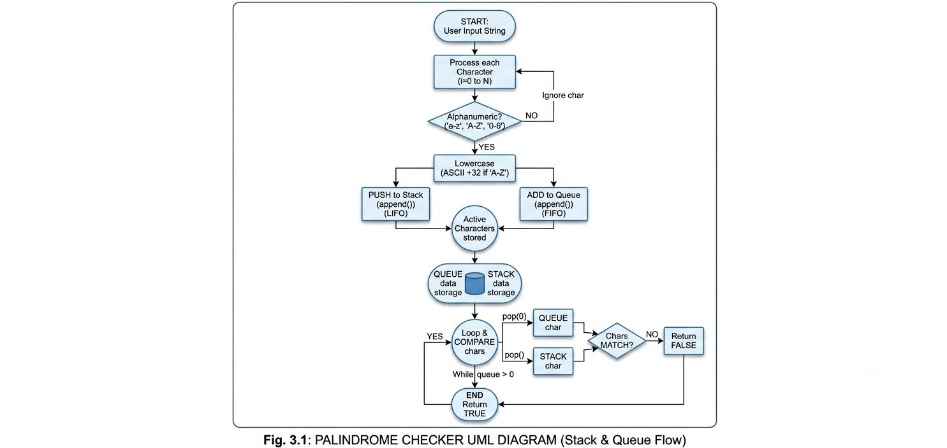
UML

DIAGRAM

SYSTEM REQUIREMENT

- HARDWARE REQUIRMENTS

Operating System: Windows 10/11 64-bit / Linux Mint / Ubuntu

Processor Type: Intel Core i3 / Core i5 or higher

RAM: Minimum 2 GB (4 GB recommended)

Processor Speed: 2.0 GHz or higher

Hard Disk: 10 GB available space

SOFTWARE REQUIRMENTS

  - Jupyter

  - Languages: Python

SYSTEM DESIGN

Existing System:

The existing string verification systems leverage various algorithms and technologies to validate character sequences and detect symmetry based on string properties. These systems are implemented across diverse software applications, including text editors, search engines, compiler parsers, and bioinformatics analysis platforms.
Key components of string validation models typically include:
Built-in String Reversal Functions (e.g., str[::-1] or reverse())
Two-Pointer Array Traversal
Regular Expression (Regex) Sanitation High-Level String Library Methods

Proposed System:

The proposed system aims to develop a string palindrome checking model using core linear data structures in Python to evaluate the structural symmetry of user-provided strings based on character sequence and manual ASCII filtering.
It offers a comprehensive solution for delivering accurate text pattern verification, facilitating algorithmic learning and enhancing the overall efficiency of character sequence analysis.
Data Collection and Preprocessing (Input handling and character extraction)
ASCII Sanitation and Case Normalization (Manual filtering and conversion offset by 32)
Linear ADT Storage (Pushing to Stack and enqueueing to Queue)
Dual-Ended Character Extraction (LIFO popping and FIFO dequeueing)
Symmetry Verification and Output Generation (Character matching and boolean result reporting

Fig 5.1: ER Diagram
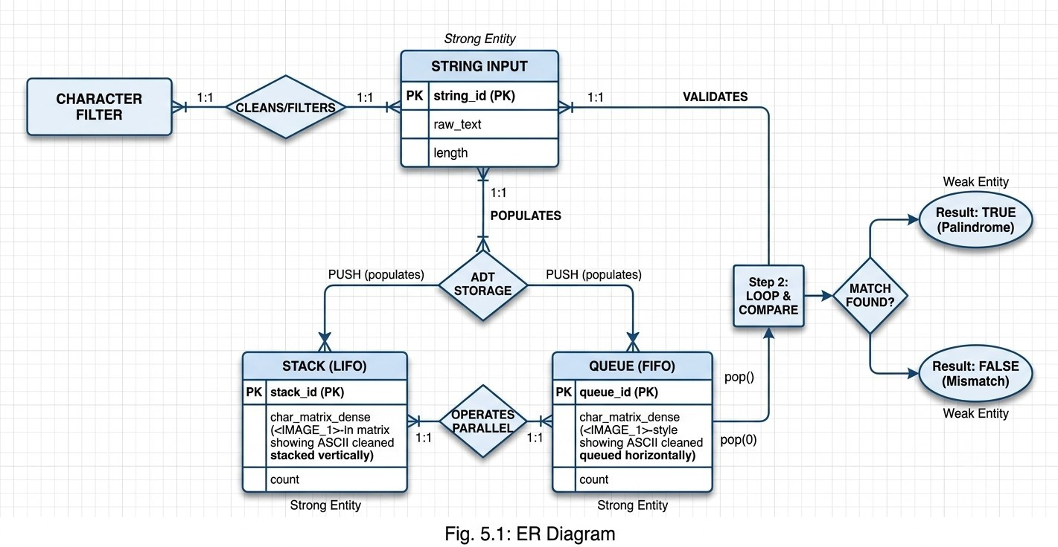
Project Name
BVCOEL,

Department

Of

computer

Engineering
7
Entity

Relationship

Diagram:

SYSTEM CODE

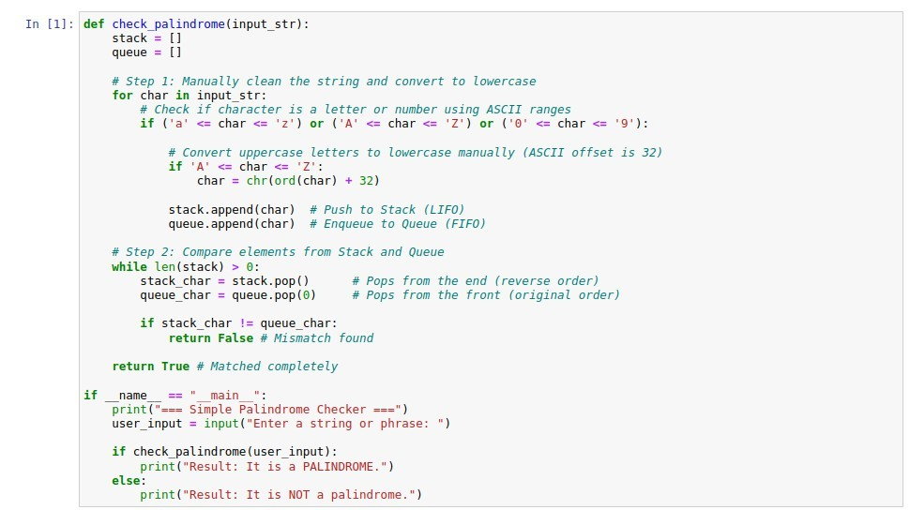
Fig 5.2: System code
Project Name
BVCOEL,

Department

Of

computer

Engineering
8
SYSTEM

CODE
RESULT

APPLICATIONS

The applications of a String Palindrome Checker project demonstrate the versatility and practicality of linear data structures developed using Python, offering value across various computer science and software development scenarios.
Text editing and processing software like integrated development environments (IDEs), word processors, or code linters can utilize palindrome and string symmetry algorithms to validate syntax blocks, brackets, and structural tokens. By analyzing character sequences, these applications can enhance error detection and code formatting, leading to increased developer productivity and software reliability.
Bioinformatics and DNA sequencing platforms analyzing genetic information can implement linear data structure algorithms to detect palindromic nucleotide sequences and restriction enzyme recognition sites. This can improve the overall accuracy of genomic analysis, facilitate genetic research, and encourage reliable data verification.
Natural language processing (NLP) and linguistic analysis websites or search engines can integrate string symmetry and queue-stack algorithms to process word patterns, analyze palindrome phrases, and perform syntax validation. This can help researchers discover structural patterns that align with linguistic rules, enhancing user engagement and analytical capability on the platform

FUTURE WORK

The future of the String Palindrome Checker project may involve experimenting with advanced linear and non-linear data structures, such as Doubly Linked Lists, Deques (collections.deque), or tree-based approaches like Suffix Trees and Trie data structures, to compare their time and space complexity with the Stack-and-Queue-based model.
By exploring these avenues for future work, you can continue to enhance the effectiveness, scalability, and performance of your string verification system, ultimately providing more efficient and versatile pattern-matching solutions for real-world software applications

CONCLUSION

In this project, we successfully developed a String Palindrome Checker using linear data structures (Stack and Queue) in Python. The goal was to create a verification model that can accurately evaluate character sequences and determine string symmetry based on fundamental data structure operations.
We started by exploring and understanding string preprocessing techniques, which clean and format input data. Preprocessing steps included manual character filtering, stripping punctuation and spaces, and performing ASCII arithmetic for lowercase normalization to transform raw text into a suitable format for linear ADT storage and comparison.

REFERENCE

Goodrich, M. T., Tamassia, R., & Goldwasser, M. H. (2013). Data Structures and Algorithms in Python. John Wiley & Sons.

Cormen, T. H., Leiserson, C. E., Rivest, R. L., & Stein, C. (2009). Introduction to Algorithms (3rd ed.). MIT Press.

Knuth, D. E. (1997). The Art of Computer Programming, Volume 1: Fundamental Algorithms (3rd ed.). Addison-Wesley.

Miller, B. N., & Ranum, D. L. (2011). Problem Solving with Algorithms and Data Structures Using Python. Franklin, Beedle & Associates.

